# 实验二

## 运行结果

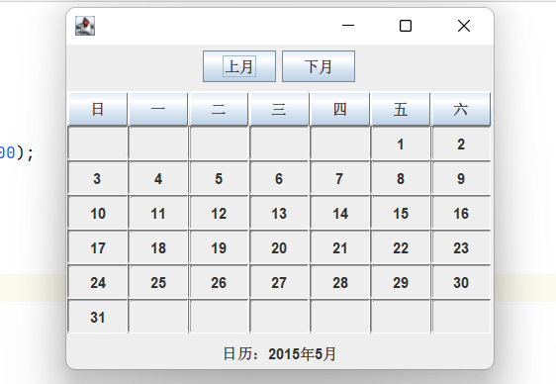

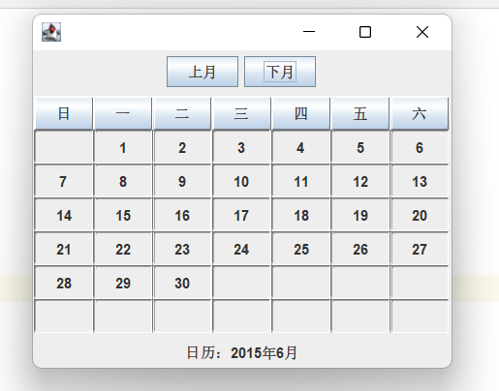

## 代码截图

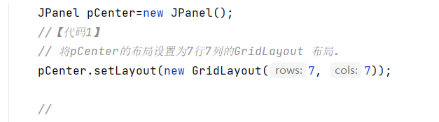

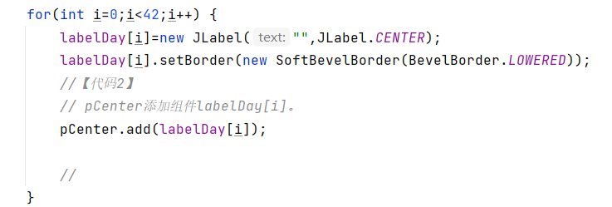

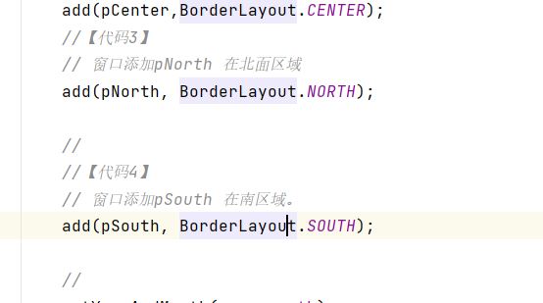

## 代码

package chapter9_2;

public class CalendarMainClass {

public static void main(String args[]) {

CalendarFrame frame=new CalendarFrame();

frame.setBounds(100,100,360,300);

frame.setVisible(true);

frame.setYearAndMonth(2015,5);

}

}

//

package chapter9_2;

import java.util.Calendar;

public class CalendarBean {

String day[];

int year=2005,month=0;

public void setYear(int year) {

this.year=year;

}

public int getYear() {

return year;

}

public void setMonth(int month) {

this.month=month;

}

public int getMonth() {

return month;

}

public String[] getCalendar() {

String a[]=new String[42];

Calendar 日历=Calendar.getInstance();

日历.set(year,month-1,1);

int 星期几=日历.get(Calendar.DAY_OF_WEEK)-1;

int day=0;

if(month==1||month==3||month==5||month==7||month==8||month==10||month==12)

day=31;

if(month==4||month==6||month==9||month==11)

day=30;

if(month==2) {

if(((year%4==0)&&(year%100!=0))||(year%400==0))

day=29;

else

day=28;

}

for(int i=星期几,n=1;i<星期几+day;i++) {

a[i]=String.valueOf(n) ;

n++;

}

return a;

}

}

//

package chapter9_2;

import java.util.*;

import java.awt.*;

import java.awt.event.*;

import javax.swing.*;

import javax.swing.border.*;

public class CalendarFrame extends JFrame implements ActionListener {

JLabel labelDay[]=new JLabel[42];

JButton titleName[]=new JButton[7];

String name[]={"日","一","二","三", "四","五","六"};

JButton nextMonth,previousMonth;

CalendarBean calendar;

JLabel showMessage=new JLabel("",JLabel.CENTER);

int year=2011,month=2;

public CalendarFrame() {

JPanel pCenter=new JPanel();

//【代码1】

// 将pCenter的布局设置为7行7列的GridLayout 布局。

pCenter.setLayout(new GridLayout(7, 7));

//

for(int i=0;i<7;i++) {

titleName[i]=new JButton(name[i]);

titleName[i].setBorder(new SoftBevelBorder(BevelBorder.RAISED));

pCenter.add(titleName[i]);

}

for(int i=0;i<42;i++) {

labelDay[i]=new JLabel("",JLabel.CENTER);

labelDay[i].setBorder(new SoftBevelBorder(BevelBorder.LOWERED));

//【代码2】

// pCenter添加组件labelDay[i]。

pCenter.add(labelDay[i]);

//

}

calendar=new CalendarBean();

nextMonth=new JButton("下月");

previousMonth=new JButton("上月");

nextMonth.addActionListener(this);

previousMonth.addActionListener(this);

JPanel pNorth=new JPanel(),

pSouth=new JPanel();

pNorth.add(previousMonth);

pNorth.add(nextMonth);

pSouth.add(showMessage);

add(pCenter,BorderLayout.CENTER);

//【代码3】

// 窗口添加pNorth 在北面区域

add(pNorth, BorderLayout.NORTH);

//

//【代码4】

// 窗口添加pSouth 在南区域。

add(pSouth, BorderLayout.SOUTH);

//

setYearAndMonth(year,month);

setDefaultCloseOperation(DISPOSE_ON_CLOSE);

}

public void setYearAndMonth(int y,int m) {

calendar.setYear(y);

calendar.setMonth(m);

String day[]=calendar.getCalendar();

for(int i=0;i<42;i++)

labelDay[i].setText(day[i]);

showMessage.setText("日历："+calendar.getYear()+"年"+ calendar.getMonth()+"月" );

}

public void actionPerformed(ActionEvent e) {

if(e.getSource()==nextMonth) {

month=month+1;

if(month>12)

month=1;

calendar.setMonth(month);

String day[]=calendar.getCalendar();

for(int i=0;i<42;i++) {

labelDay[i].setText(day[i]);

}

}

else if(e.getSource()==previousMonth) {

month=month-1;

if(month<1)

month=12;

calendar.setMonth(month);

String day[]=calendar.getCalendar();

for(int i=0;i<42;i++)

labelDay[i].setText(day[i]);

}

showMessage.setText("日历："+calendar.getYear()+"年"+calendar.getMonth()+"月" );

}

}